SALES DATA ENGINEERING AND QUERY OPTIMIZATION USING SNOWFLAKE
STEP 1: SNOWFLAKE ENVIRONMENT SETUP
1.1 Objective
The objective of this step is to create a new Snowflake environment for implementing a sales data engineering and analytical workflow.
The environment consists of a database, separate schemas for raw and cleaned datasets, and a virtual warehouse for executing SQL queries.
The resources are created with consistent naming conventions to organize the sales datasets and support subsequent data ingestion, cleaning, transformation, analysis, and query optimization activities.
1.2 Database Creation
A new database named SALES_ANALYTICS_DB is created to store all the database objects required for the sales analytics project.
SQL Command:
CREATE DATABASE SALES_ANALYTICS_DB;
Explanation:
- CREATE DATABASE creates a new database in Snowflake.
- SALES_ANALYTICS_DB is the name assigned to the database.
The database acts as the main container for the schemas and tables used in this project.
Screenshot 1: Database Creation
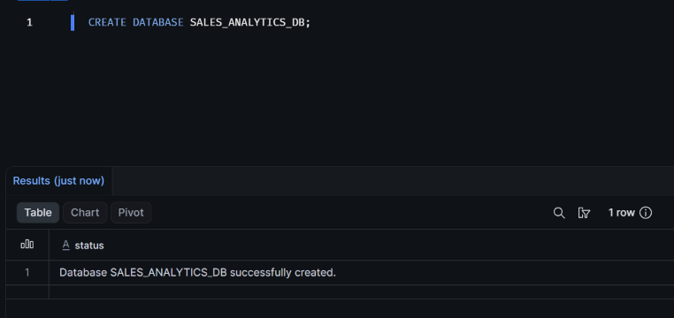1.3 Schema Creation
Two schemas are created inside the database to organize the datasets based on their processing stages.
SQL Commands:
CREATE SCHEMA SALES_ANALYTICS_DB.SALES_RAW;

CREATE SCHEMA SALES_ANALYTICS_DB.SALES_CLEAN;
Explanation:
SALES_RAW:
This schema stores the original datasets ingested from CSV files. The raw data is preserved to maintain the original source information.
SALES_CLEAN:
This schema stores cleaned and transformed datasets that are prepared for analytical operations.
Separating raw and cleaned data helps maintain data organization and prevents modifications to the original datasets during transformation.
Screenshot 2: Schema Creation
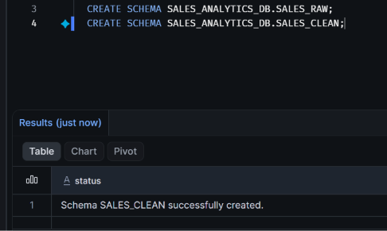1.4 Virtual Warehouse Creation
A virtual warehouse named SALES_ANALYTICS_WH is created to provide the computational resources required to execute SQL queries and perform data processing operations.
SQL Command:
CREATE WAREHOUSE SALES_ANALYTICS_WH
WITH
WAREHOUSE_SIZE = 'XSMALL'
AUTO_SUSPEND = 60
AUTO_RESUME = TRUE
INITIALLY_SUSPENDED = TRUE;
Explanation of Parameters:
Parameter | Description
WAREHOUSE_SIZE | Specifies the compute size of the warehouse. XSMALL is selected for this practical.
AUTO_SUSPEND | Automatically suspends the warehouse after 60 seconds of inactivity.
AUTO_RESUME | Automatically resumes the warehouse when a query requires it.
INITIALLY_SUSPENDED | Creates the warehouse in a suspended state.
The XSMALL warehouse is selected because the project uses relatively small practice datasets.
Automatic suspension and resumption help manage warehouse usage.
Screenshot 3: Virtual Warehouse Creation
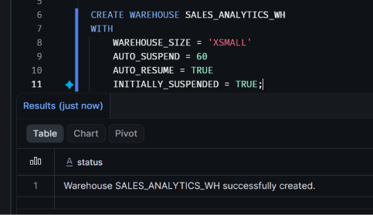
1.5 Selecting the Database, Schema and Warehouse
After creating the required resources, the database, schema, and warehouse are selected for subsequent operations.
SQL Commands:
USE WAREHOUSE SALES_ANALYTICS_WH;

USE DATABASE SALES_ANALYTICS_DB;

USE SCHEMA SALES_RAW;
Explanation:
- USE WAREHOUSE selects the virtual warehouse that will execute SQL queries.
- USE DATABASE selects the database in which the project operations will be performed.
- USE SCHEMA selects the raw schema as the current working schema.
These commands establish the working context for subsequent database operations.
1.6 Environment Verification
The current Snowflake configuration is verified using the following SQL query.
SQL Command:
SELECT
CURRENT_DATABASE() AS DATABASE_NAME,
CURRENT_SCHEMA() AS SCHEMA_NAME,
CURRENT_WAREHOUSE() AS WAREHOUSE_NAME,
CURRENT_ROLE() AS ROLE_NAME;
Explanation:
The query retrieves the currently selected database, schema, warehouse, and active user role.
This verification ensures that the required resources have been selected correctly before proceeding with data ingestion.
Expected Configuration:
Property | Expected Value
DATABASE_NAME | SALES_ANALYTICS_DB
SCHEMA_NAME | SALES_RAW
WAREHOUSE_NAME | SALES_ANALYTICS_WH
ROLE_NAME | Active Snowflake role
Screenshot 4: Environment Verification
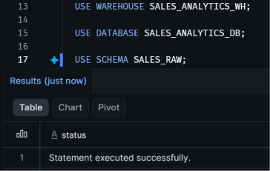
1.7 Result
The Snowflake environment setup is completed by creating the SALES_ANALYTICS_DB database, SALES_RAW and SALES_CLEAN schemas, and the SALES_ANALYTICS_WH virtual warehouse.
The required database resources are selected and verified successfully.
The environment is now ready for the next stage of the practical, which involves identifying, inspecting, and preparing multiple related sales datasets for ingestion into Snowflake.

STEP 2: DATASET IDENTIFICATION AND PREPARATION
2.1 Dataset Selection
Three related CSV datasets were selected for the sales analytics project:
- Customers: Contains customer information such as CustomerID, CustomerName, Email, City, Country and JoinDate.
- Products: Contains product information such as ProductID, ProductName, Category, UnitCost and ListPrice.
- Sales: Contains transaction information such as SaleID, OrderDate, CustomerID, ProductID, Quantity, UnitPrice, Discount and PaymentStatus.
2.2 Dataset Relationships
The datasets contain the following relationships:
- CustomerID connects the Customers and Sales datasets.
- ProductID connects the Products and Sales datasets.
These relationships will be used to perform joins and analytical operations.
2.3 Dataset Inspection
The CSV files were inspected to understand their structure, column names, data types and record counts.
Dataset | Total Records
Customers | 21
Products | 13
Sales | 61
2.4 Data Quality Observations
During initial inspection, the following potential data-quality issues were identified:
- Duplicate records.
- Missing and NULL values.
- Inconsistent text formatting and whitespace.
- Invalid and inconsistent date formats.
- Invalid numeric values.
- Invalid customer and product references.
- Inconsistent payment status values.
These issues will be addressed during the data validation and cleaning stages.
2.5 Result
Three related sales datasets were successfully prepared and inspected. Their structures, relationships and potential data-quality issues were identified for subsequent Snowflake ingestion and transformation.
STEP 3: TABLE CREATION, FILE FORMAT AND INTERNAL STAGE
3.1 Table Creation
Three tables were created in the SALES_RAW schema:
- CUSTOMER_DATA – Stores customer information.
- PRODUCT_DATA – Stores product information.
- SALES_TRANSACTIONS – Stores sales transaction records.
VARCHAR columns were initially used to preserve raw CSV values for subsequent validation and transformation.
3.2 CSV File Format Creation
A reusable CSV file format named SALES_CSV_FORMAT was created with a comma delimiter, header skipping, optional quotation marks and empty-field handling.
3.3 Internal Stage Creation
An internal stage named SALES_DATA_STAGE was created to store the CSV files before loading them into the corresponding Snowflake tables.
3.4 Verification
The SHOW TABLES, SHOW FILE FORMATS and SHOW STAGES commands were executed to verify the created database objects.
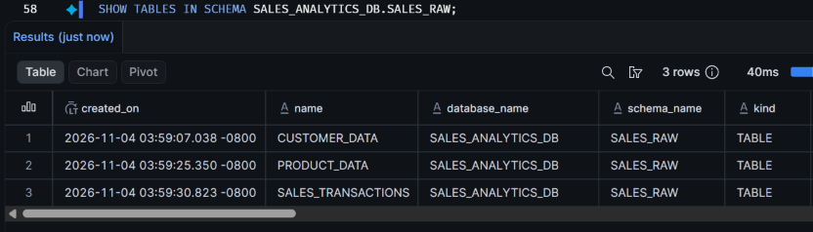
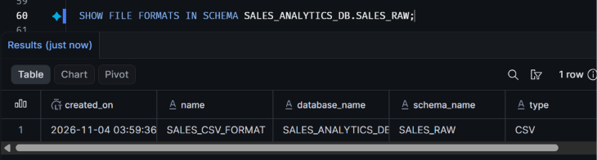
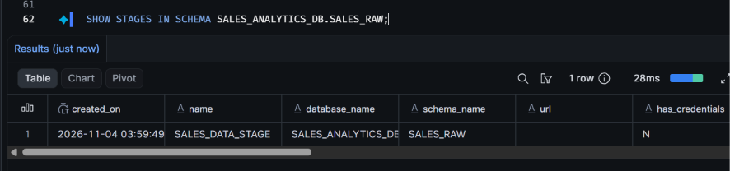
3.5 Result
Three raw tables, one CSV file format and one internal stage were created successfully in the SALES_RAW schema.

STEP 4: CSV UPLOAD AND DATA INGESTION
4.1 CSV File Upload
The customers.csv, products.csv and sales.csv files were uploaded to the Snowflake internal stage SALES_DATA_STAGE using Snowsight.
4.2 File Verification
The LIST command was executed to verify the uploaded files in the internal stage.
4.3 Data Loading
The COPY INTO command was used to load the three CSV files into their corresponding raw tables:
- customers.csv → CUSTOMER_DATA
- products.csv → PRODUCT_DATA
- sales.csv → SALES_TRANSACTIONS
The ON_ERROR option was set to CONTINUE to allow valid records to load while reporting records that could not be processed.
4.4 Record Count Verification
COUNT(*) queries were executed on all three tables to verify the number of successfully loaded records.
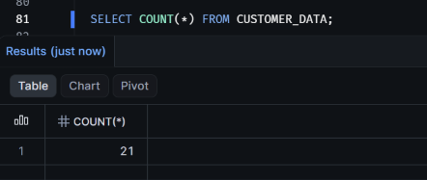
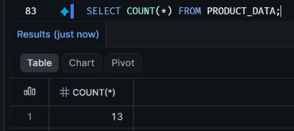
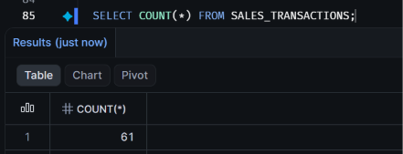
4.5 Result
The CSV datasets were uploaded to the internal stage and loaded into their corresponding Snowflake raw tables. Loading results and record counts were inspected.

STEP 5: DATA EXPLORATION AND VALIDATION
5.1 Displaying Records
SELECT * queries were executed on the Customers, Products and Sales tables to inspect the imported records.
5.2 Filtering Records
WHERE conditions were used to retrieve specific records based on payment status.
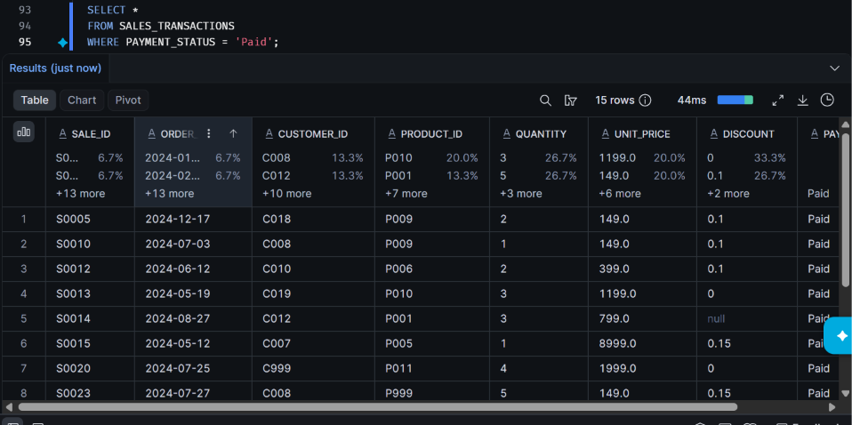
5.3 NULL Value Identification
Queries using IS NULL and TRIM() were executed to identify missing and empty values in important columns. 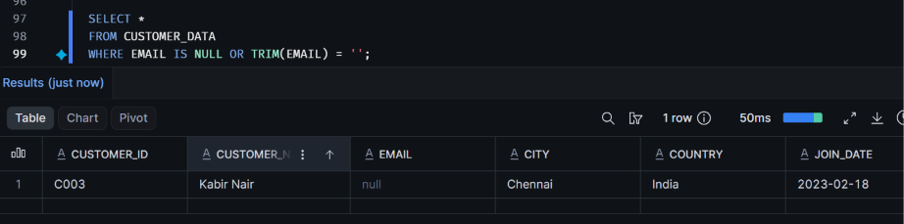
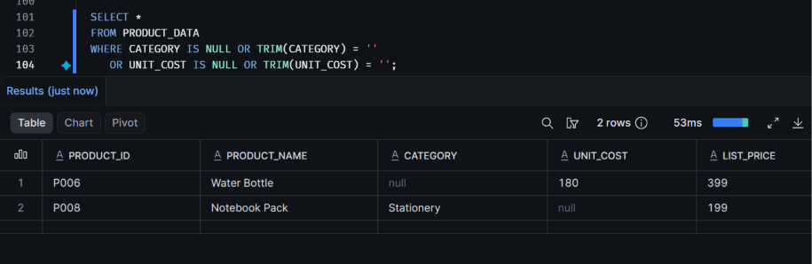
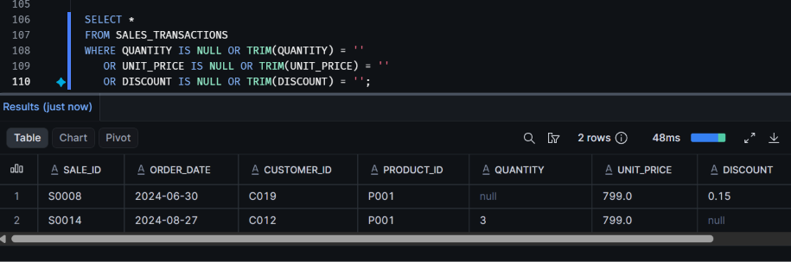
5.4 Result
The raw datasets were explored, filtered and inspected. Missing values and columns requiring data type conversion were identified for subsequent cleaning and transformation.

STEP 6: HANDLING NULL VALUES AND DATA TYPE CONVERSION
6.1 NULL Value Handling
Missing values were handled according to the nature of each column.
- Missing customer emails were replaced with 'Not Provided'.
- Missing country values were replaced with 'Unknown'.
- Missing product categories were replaced with 'Uncategorized'.
- Unknown product costs and quantities were retained as NULL.
- Missing sales discounts were treated as zero.
6.2 Data Type Conversion
TRY_TO_DATE, TRY_TO_NUMBER and TRY_TO_DECIMAL functions were used to convert raw string values into appropriate date and numeric data types.
TRIM and INITCAP functions were applied to standardize text values.
6.3 Cleaned Table Creation
Three cleaned tables were created in the SALES_CLEAN schema:
- CLEAN_CUSTOMERS
- CLEAN_PRODUCTS
- CLEAN_SALES
The original raw tables were preserved.
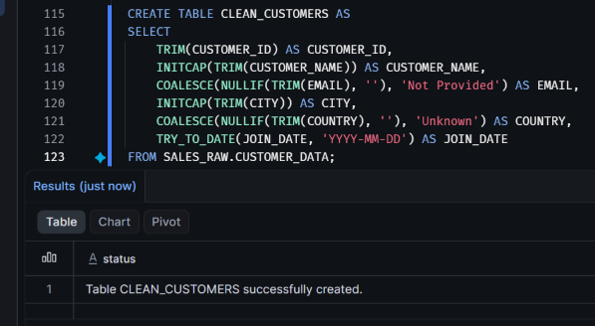
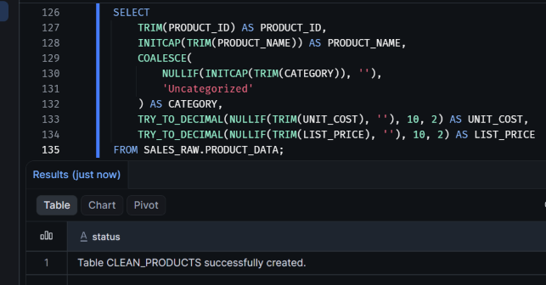
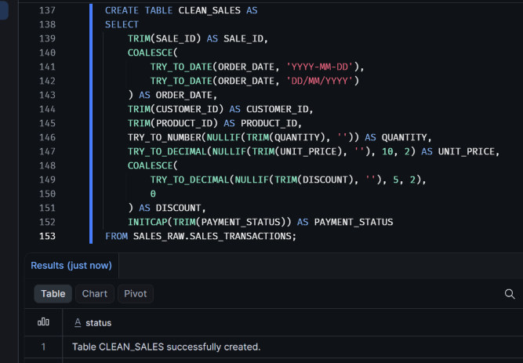
6.4 Verification
DESC TABLE commands were used to verify the converted column data types.
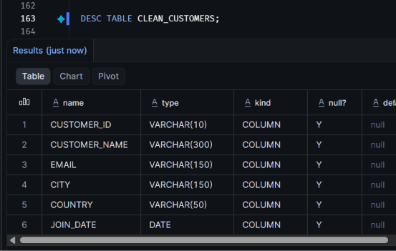
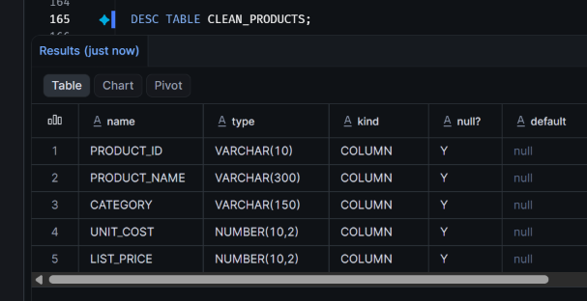
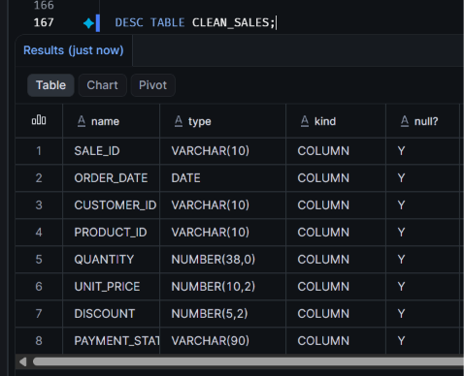
6.5 Result
Cleaned tables were created with standardized text values, handled missing values and converted date and numeric columns. Invalid values requiring further investigation were retained as NULL for subsequent validation.

7.1 Duplicate Record Handling
Duplicate records were identified and removed from the Customers, Products and Sales datasets using ROW_NUMBER() and QUALIFY. This ensured that the final tables contained unique records based on their respective IDs.

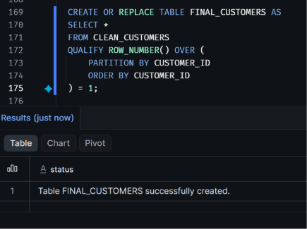
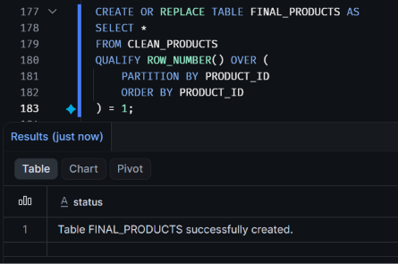

STEP 8: ANALYTICAL SQL QUERIES
8.1 Data Filtering
WHERE clauses were used to retrieve and filter records from the final tables.
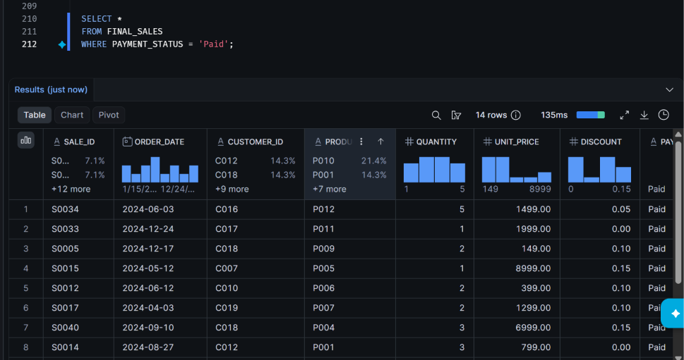
8.2 Total Sales Calculation
SUM() was used to calculate total sales revenue from paid transactions after applying discounts.
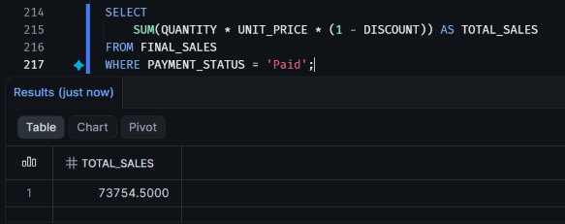
8.3 Product-wise and Customer-wise Analysis
JOIN, GROUP BY and aggregate functions were used to calculate sales quantities and revenue for individual products and customers.
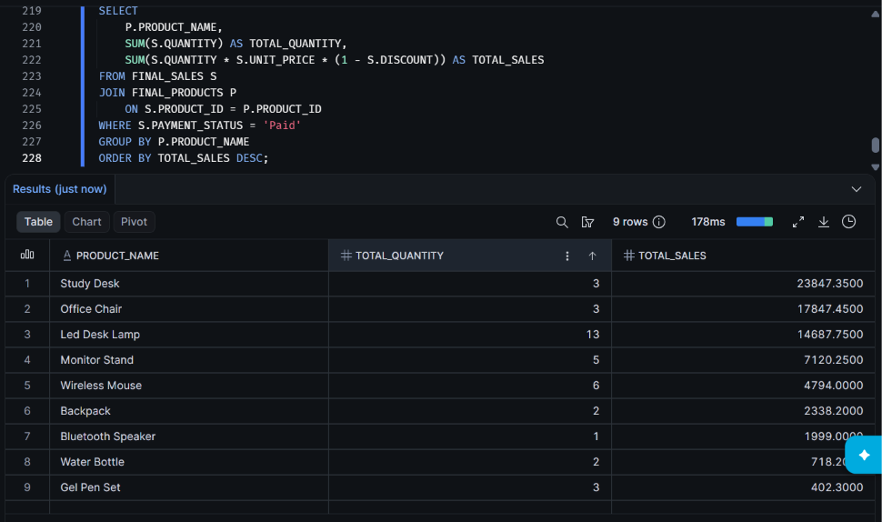

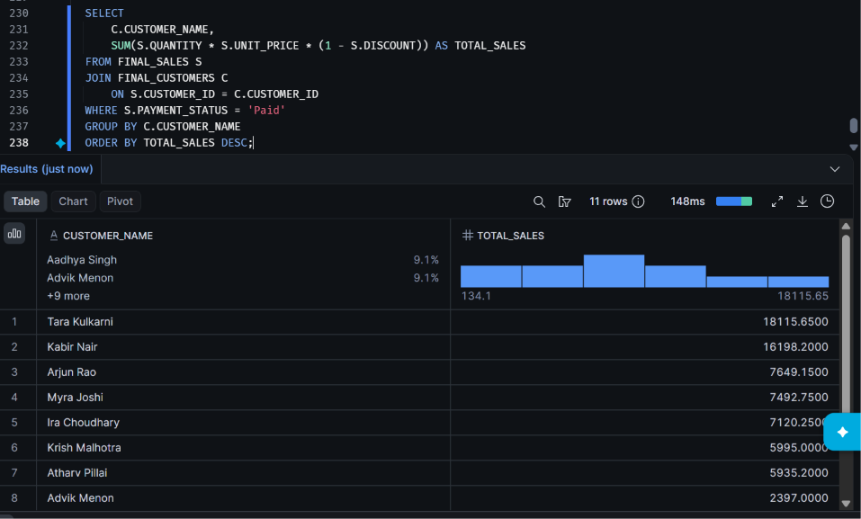
8.4 Combining Multiple Tables
The Customers, Products and Sales tables were joined using their common IDs to retrieve combined sales information.
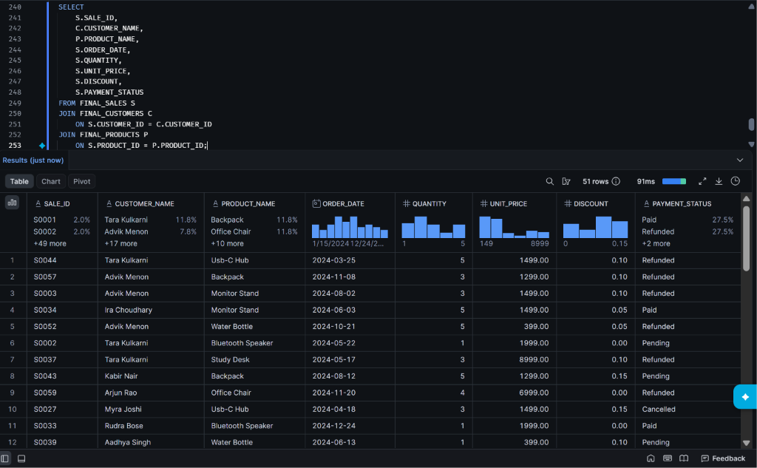
8.5 Result
Analytical SQL queries were executed to retrieve, filter and analyze sales data across multiple related tables.

STEP 9: SQL QUERY OPTIMIZATION
9.1 Original Query
A product-wise sales query was executed using JOIN, WHERE and GROUP BY operations to calculate total sales for each product.
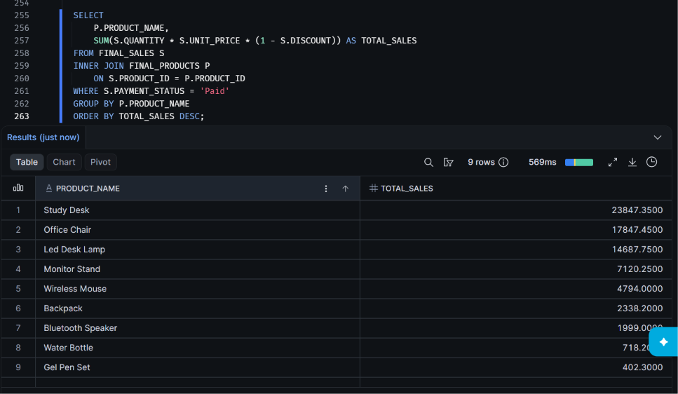
9.2 Optimized Query
The query was rewritten using a CTE to filter paid transactions and aggregate sales before joining the product table.
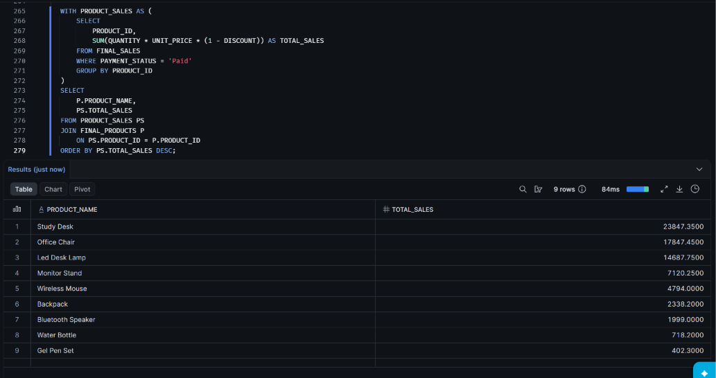
9.3 Performance Comparison
Both queries were executed and their results, execution times and query IDs were recorded for comparison.
9.4 Result
Original and optimized SQL queries were prepared to study the impact of filtering, aggregation and query structure on execution performance.

STEP 10: QUERY PROFILE ANALYSIS
10.1 Query Profile Inspection
Snowflake Query Profile was used to inspect the execution plans of the original and optimized queries.
10.2 Performance Metrics
The following details were examined:
- Query execution time.
- Data scanned.
- Table scan operations.
- Join operations.
- Aggregation operations.
- Other relevant execution statistics.
10.3 Performance Comparison
The execution statistics of both queries were compared to understand the effect of query restructuring and optimization.
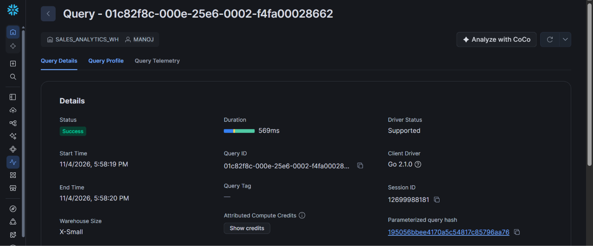
GENERAL QUERY
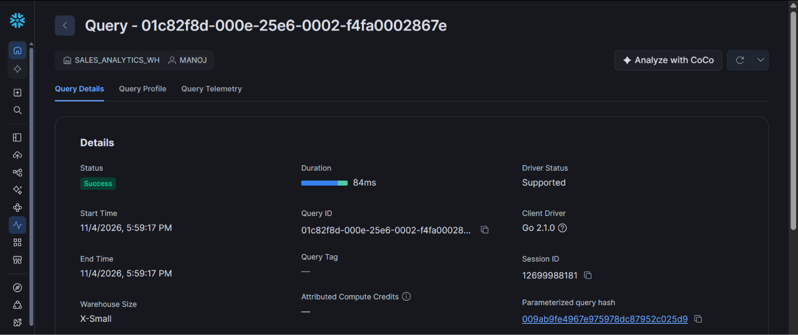
OPTIMIZED QUERY
-> Duration of Optimized query is 8x faster than General query
10.4 Result
Query Profile provided information about query execution and processing operations. The comparison helped evaluate the effectiveness of the applied optimization techniques.

